Chapter 18, Solution 56.

(a) 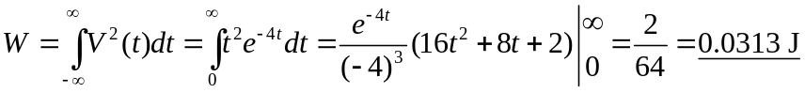

- In the frequency domain,
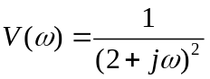

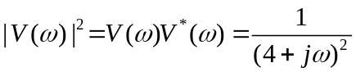
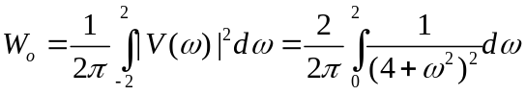

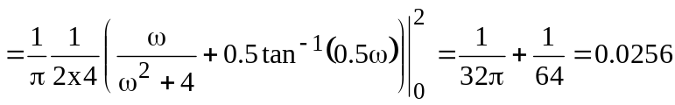

Fraction =